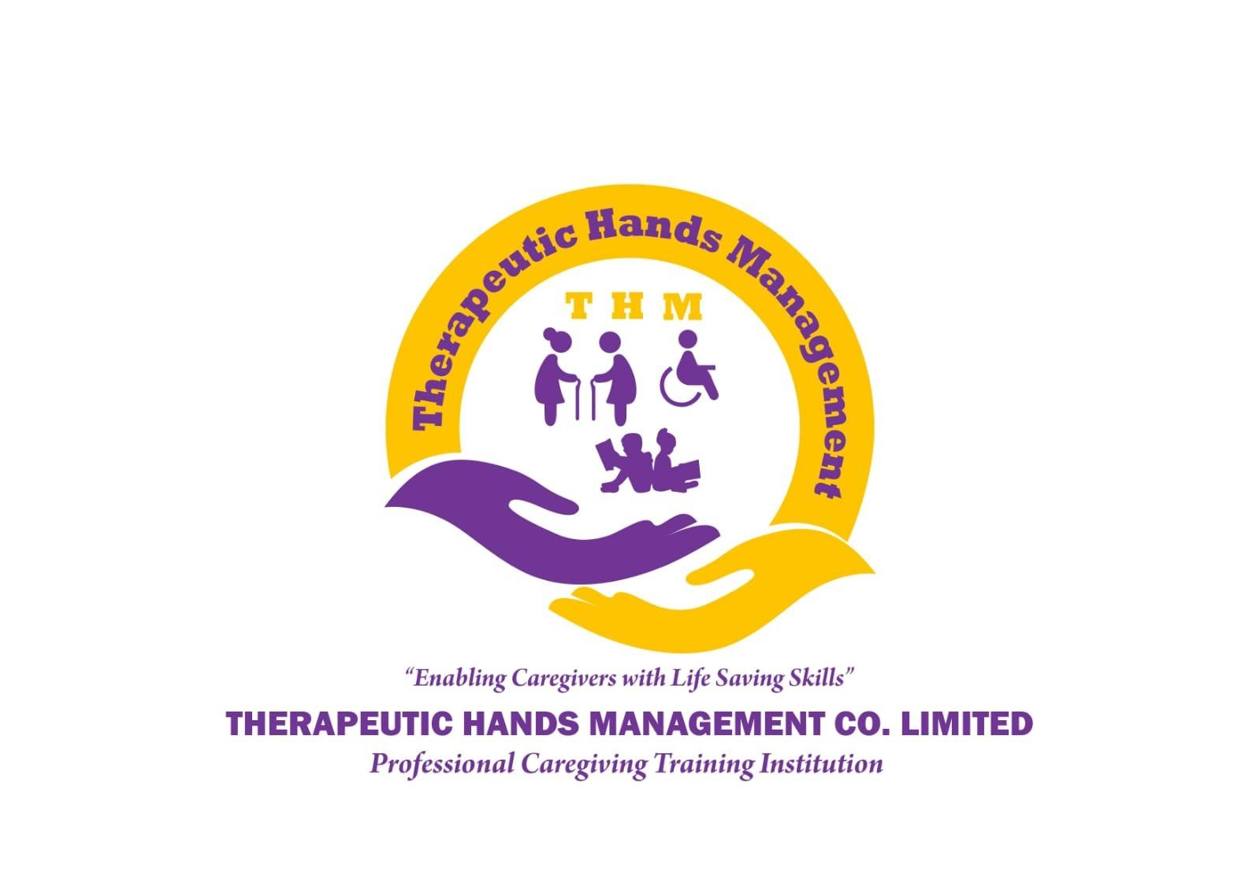
PROFILE
THERAPEUTIC HANDS MANAGEMENT CO. LIMITED (THM)
NEW WAUMINI HOUSE, 3rd Floor, WESTLANDS
P. O BOX 27268 – 00100
NAIROBI, KENYA
TEL: 0722 590 457 / 0700 589 647
E-mail: info@thm.co.ke
CONTACT PERSON
Mrs. Janipher Aluoch Otieno
Chief Executive Officer – THM
May 2026
INTRODUCTION

THERAPEUTIC HANDS MANAGEMENT PROFILE
Therapeutic Hands Management (THM) is a Limited Company registered in April 2023, to operate in Kenya and train Caregivers using National Industrial Training Authority (NITA) Curriculum. We train our students to be highly qualified caregivers. The approach in training is holistic hence the caregivers have compassion, good communication empathy, they are caring and competence in their work. The training gives youth job opportunities at the hospital and even at home where a discharged patient needs nursing care as they recover.
THM endeavors to maintain professional relationships with clients, to improve services continually, and to work closely with the government regulatory institutions for guidance on current requirements on the curriculum. THM Caregiver graduates are already working in various places including in some hospitals under the supervision of registered nurses, some take care of the elderly in the homes and others also provide care to the children. The trained caregivers can also work in individual homes to provide home based care for aging parents who need the specialized care at home.
Since 2023, THM has graduated over 150 Caregivers who are out in the market place either working or looking forward to provide services at opportune time. This year, 2026, THM is in partnership with CHANCEN International, which is an NGO with a program for less privileged youth between 19 and 35 years of age under the project “Study Now, Pay later”. CHANCENT funds your education today. You repay only when you finish your studies. There is no fees upfront and there is no collateral. In six years, CHANCEN has financed the education of over 9,000 students with a graduation rate of 93%. If you are interested in taking the course of caregiving, you can trust CHANCEN to support your education in Certificate in Caregiver II at Therapeutic Hands Management.

VISION
To be a household name and a pace-setter in the caregiving global market, empowering caregivers with specialized skills that meet every client’s needs by God’s grace.

MISSION
To equip caregivers with high quality skills that enables them to safeguard children & adults at risk with empathy, love and respect.

CORE VALUES
- Accountability
- Confidentiality
- Compassion
- Communication
- Equality
- Kindness
- Integrity

STRUCTURE
- Board of Governors
- Management Team
- Tutors
- Students and parents/guardians

PURPOSE
The purpose of THM’s existence is to prepare the Caregivers with the necessary knowledge that allows them to learn the practical/clinical ways of caring from the Registered Nurses at the hospital during rotations. This enables the trainee to practice the knowledge and skills they have learned in class. After Covid, many people have opted to have their patients taken care of at home once they have been diagnosed and are under treatment. This is where the Caregivers come in handy, they are able to assist the patients at home, explain to the Nurse in Charge every step observed and follow instructions as given until the patient is stable.

THE SCOPE
THM trains Caregivers to provide great patient care; they are expected to answer patient calls and to determine how best to help them. They are able to provide physical support for patients or clients with daily activities and personal hygiene including bathing, dressing, grooming, getting out of bed, using the toilet, walking, standing, or exercising.

PROCEDURES AND SKILLS
The Objectives of THM for this course include the following areas of learning:
- To equip Caregivers with skills to help patients with their basic needs.
- To demonstrate to Caregivers how to bathe, dress and feed the patients.
- To expose the Caregivers to various cases of patients they expect to meet in the field including stroke patients, victims of various circumstances, the elderly, or individuals recovering from an accident, injuries or surgeries in a hospital.

Areas of Learning by the Caregivers
The learning covers the listed areas:
- Hand hygiene
- Proper gloving
- Bed making
- Disinfection and decontamination
- Back care
- Vital taking
- Bedpan administration
- Catheter care and perineum care
- Tube feeding
- Wheelchair transfer
- Hot and cold therapy
- Proper use of medical equipment
- Use of comfort devices
- Positioning
- Use of assistive devices
- Proper waste management
- Bed bath
- Standard precautions
- Transmission based precautions
- Sugar level monitoring
- Oxygen administration
- Patient grooming

COLLABORATION
THM is collaborating with various stakeholders to provide practical learning experience to trained Caregivers and to provide jobs for the qualified Caregivers:
- Hospital / Healthcare providers
- Homecare Institutions
- Elderly Care homes
- Childcare Centres
- Individual homes in need of caregiving and healthcare services

Marketing Strategy
THM has engaged an organization that does marketing by coming to the institution and taking videos that is used for marketing. The staff and the students are interviewed on what they do at the institution. Parts of the video recording is used in the website and social media for marketing the institution.

Counties of operation
THM is training Caregivers in Nairobi County band in Kisumu County currently.

